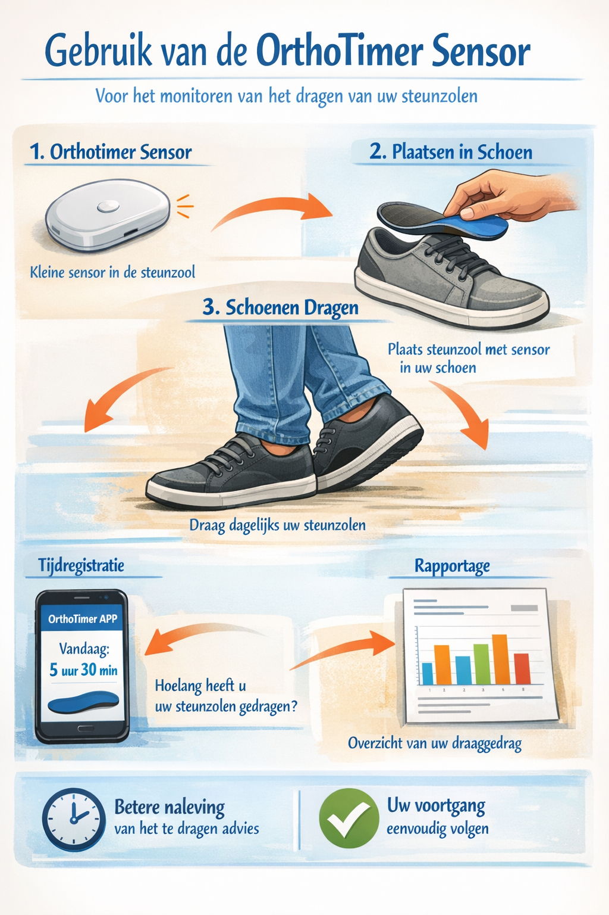
Appendix 29: Patient Leaflet on Orthotimer sensor

